

Functional design
Hivos IATI for The Netherlands
Ministry of Foreign Affairs

Barry de Graaff
Annemarie Stolp
Table of Contents
Introduction 3
Scope 4
Requirements 4
Program Funding Use Case 5
Osiris contracts 6
Osiris Business Partners 6
IATI Identifier 6
IATI Activity file 7
Activities 7
(4.1.1) iati-activities 7
(4.1.2) iati-activities→iati-activity 7
(4.1.3) iati-activities→iati-activity→reporting-org 7
(4.1.3) iati-activities→iati-activity→iati-identifier 8
(4.1.4) iati-activities→iati-activity→title 8
(4.1.4) iati-activities→iati-activity→description->narrative 8
(4.1.4) iati-activities→iati-activity→activity-status 8
(4.1.4) iati-activities→iati-activity→activity-date 9
(4.1.4) iati-activities→iati-activity→contact-info 9
(4.1.4) iati-activities→iati-activity→contact-info->telephone 9
(4.1.4) iati-activities→iati-activity→contact-info->email 9
Assessment (webform) 10
IATI all baseline data 10
IATI result data 10
Report for staff overview 10
(4.1.5) iati-activities→iati-activity→participating-org 11
(4.1.6) iati-activities→iati-activity→recipient-country 13
(4.1.6) iati-activities→iati-activity→recipient-region 13
(4.1.7) iati-activities→iati-activity→sector 14
(4.1.7) iati-activities→iati-activity→policy-marker 15
(4.1.7) iati-activities→iati-activity→default-flow-type 16
(4.1.7) iati-activities→iati-activity→default-finance-type 16
(4.1.7) iati-activities→iati-activity→default-aid-type 17
(4.1.7) iati-activities→iati-activity→default-tied-status 17
Budget 18
(4.1.8) iati-activities→iati-activity→budget 19
(4.1.8) iati-activities→iati-activity→budget→value 19
Transactions 20
4.1.8) iati-activities→iati-activity→transaction (type 1) 21
4.1.8) iati-activities→iati-activity→transaction→value 21
4.1.8) iati-activities→iati-activity→transaction (type 2) 22
4.1.8) iati-activities→iati-activity→transaction→value 22
4.1.8) iati-activities→iati-activity→transaction (type 3 or 4) 23
4.1.8) iati-activities→iati-activity→transaction→value 23
4.1.8) iati-activities→iati-activity→transaction (type 11) 24
4.1.8) iati-activities→iati-activity→transaction→value 24
4.1.9) iati-activities→iati-activity→document-link 25
4.1.10) iati-activities→iati-activity→related-activity 26
4.1.11) iati-activities→iati-activity→result 27

Introduction
This document describes how Hivos plans to implement the Publication Guidelines for partners, contractors and suppliers as released by The Netherlands Ministry of Foreign Affairs on December 1st 2015.

The guidelines are available online via:
https://www.government.nl/binaries/government/documents/publications/2015/12/01/open-data-and-development-cooperation/how-to-use-the-iati-standard-1.pdf

Hivos already publishes an IATI activity file for the entire organisation, but for the Dutch government data must be represented in a different form and also different performance indicators must be added.

The head of the current IATI activity file implemented in PL/SQL looks like this
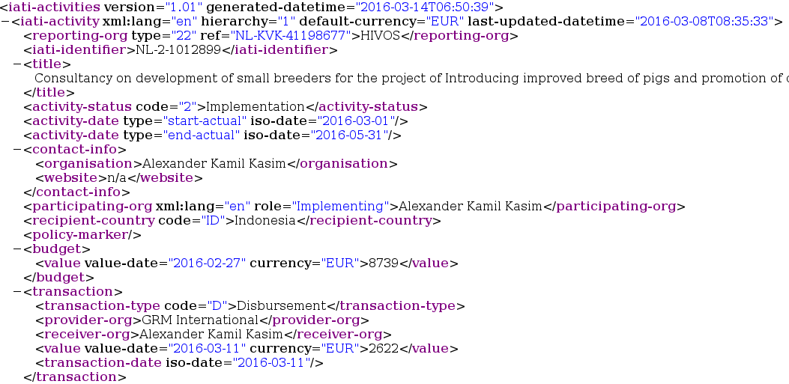
Figure 1: Hivos IATI 1.01 XML

Scope
Hivos will provide one activity file that is limited to the following Osiris project clusters also known as strategic partnerships:
- Green and inclusive energy (id: 1006710)
- Sustainable diets 4 all (id: 1006709)
- Open contracting (id: 1006708)
- Women at work (id: 1006707)
And the following project clusters:
- Flow Women Empowered (id: 1006719)
- Lead Mideast Creatives - Youth Entrepreneurship (id: 1006701)
And the following funds:
- Strategic Partnerships fund (documentno: 1000517, id: 1010612)
- Flow fund (documentno: 1000518, id: 1010613)
- Lead fund (documentno: 1000519, id: 1010614)

Requirements
- IATI standard version 2.02 or higher.
- Valid XML http://validator.iatistandard.org/
- Frequency – uploaded on a quarterly basis
- Preferably English

Organisations with more than one agreement with the ministry may choose to publish all activities in one comprehensive IATI publication
Your IATI activity file should at least contain all the activities which are funded by the Ministry of Foreign Affairs. If the support to these activities is used to implement (underlying) activities, you should also publish these in your data.

Program Funding Use Case
The following 2 paragraphs are taken from the Guidelines directly:
In order to achieve meaningful IATI publications, that provide understandable insights for all your partners and meet the requirements to serve as an official progress report about your activities, the ministry has developed a model to set up an IATI publication based on use cases.
Program Funding
Definition: an organisation is funded to carry out a specific program or series of activities. As a result of this funding, a series of activities are planned. Those activities lead to outflows from the organisation.

We conclude that Hivos falls in the program funding category. The following figure illustrates the situation:

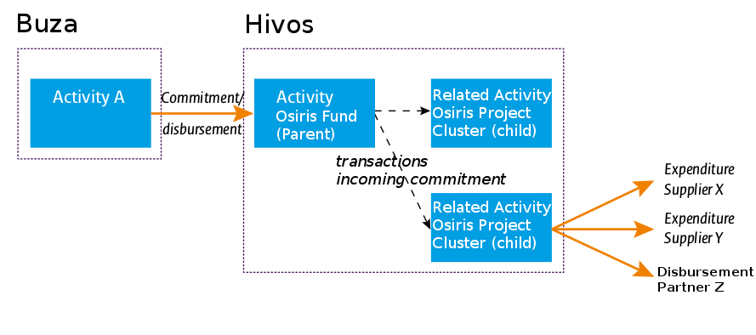
Figure 2: Program Funding Use case for Hivos and Osiris
As a result of this use case, published IATI activities will be based on both funding and project clusters in Osiris.

Osiris contracts

We create a view for the contracts table in Osiris that filters out data that we do not want to have in the IATI publication. Where in the remainder of this document is referred to afgo_commitment, contract or commitment the following view is intended:
CREATE OR REPLACE VIEW JASPER.HV_AFGO_COMMITMENT AS
SELECT * FROM AFGO_COMMITMENT
WHERE CONFIDENTIALITYSTATUS = 'P' -- filter confidential records
AND AFGO_COMMITMENT.MASTERCOMMITMENT_ID IS NULL -- filter extension contracts
AND AFGO_COMMITMENT.DOCSTATUS IN ('CO','CL'); -- filter draft, invalid, void etc.

Osiris Business Partners
We create a view for the Business Partners table in Osiris that filters out data that we do not want to have in the IATI publication. Where in the remainder of this document is referred to C_BPARTNER or Business Partner the following view is intended:
CREATE OR REPLACE VIEW JASPER.HV_C_BPARTNER AS
SELECT * FROM C_BPARTNER
WHERE CONFIDENTIALITYSTATUS = 'P'; -- filter confidential records

IATI Identifier
It is important that IATI identifiers are used consistently between publications. This means that we must use the same IATI identifiers as used in previous publications and if applicable choose new identifiers that allow for future publications. To do this we choose new identifiers following the structure in the table below.
Priority | ref attribute
0 | NL-KVK-41198677-TABLENAME-REFERENCENO (special field for IATI)  example: NL-KVK-41198677-AFGO_FUND-1234567
1 | NL-KVK-41198677-TABLENAME-DOCUMENTNO  example: NL-KVK-41198677-AFGO_COMMITMENT-1234567
2 | NL-KVK-41198677-TABLENAME-TABLE_ID  example: NL-KVK-41198677-AFGO_PROJECTCLUSTER-1234567
For activities based on contract, commitment IATI element other-identifier must be added with the ref attribute NL-2-documentno (example: NL-2-1012759) http://iatistandard.org/202/activity-standard/iati-activities/iati-activity/other-identifier/

IATI Activity file

The technical IATI standard can be accessed via the following URL, its contents are invaluable for implementing IATI publications:
http://iatistandard.org/202/activity-standard/summary-table/

Activities
The parent and child activities are described in this document as being the same. If/when information applies to only the parent or child, (P) or (C) is added for making the destinction.

(4.1.1) iati-activities
XML attribute | value
version | 2.02
generated-datetime | SYSDATE

(4.1.2) iati-activities→iati-activity
XML attribute | value
last-updated-datetime | AFGO_FUND.UPDATED (p)  AFGO_PROJECTCLUSTER.UPDATED (c)
xml:lang | en

(4.1.3) iati-activities→iati-activity→reporting-org
XML attribute | value
type | 21
ref | NL-KVK-41198677
->narrative | HIVOS
type: Hardcoded to 21 International NGO.
Argumentation (type): http://iatistandard.org/201/codelists/OrganisationType/

(4.1.3) iati-activities→iati-activity→iati-identifier
XML attribute | value
NL-KVK-41198677-AFGO_FUND-AFGO_FUND_DOCUMENTNO (p)
NL-KVK-41198677-AFGO_PROJECTCLUSTER-AFGO_PROJECTCLUSTER_ID (c)

(4.1.4) iati-activities→iati-activity→title
XML attribute | value
AFGO_FUND.DESCRIPTION (p)
AFGO_PROJECTCLUSTER.NAME (c)

(4.1.4) iati-activities→iati-activity→description->narrative
XML attribute | value
AFGO_FUND.DESCRIPTION (p)
AFGO_ASSESSMENT (c)
AFGO_CRITERIUM_ID = '1002300'
AFGO_ASSESMENTLINE.TEXTSCOREB

(4.1.4) iati-activities→iati-activity→activity-status
XML attribute | value
code | 2
 | implementation

(4.1.4) iati-activities→iati-activity→activity-date
XML attribute | value
type | 1
iso-date | AFGO_FUND.STARTDATE (p)  AFGO_PROJECTCLUSTER.STARTDATE (c)

XML attribute | value
type | 3
iso-date | AFGO_FUND.ENDDATE (p)  AFGO_PROJECTCLUSTER.ENDDATE (c)

type: 1 => Planned start, 3 => Planned end.
Argumentation (type): http://iatistandard.org/202/codelists/ActivityDateType/

(4.1.4) iati-activities→iati-activity→contact-info
XML attribute | value
type | 1
type: 1 => General Enquiries
Argumentation (type): http://iatistandard.org/202/codelists/ContactType/

(4.1.4) iati-activities→iati-activity→contact-info->telephone
XML attribute | value
 | 0031703765500

(4.1.4) iati-activities→iati-activity→contact-info->email
XML attribute | value
 | info@hivos.org
Documentation:
http://iatistandard.org/202/activity-standard/iati-activities/iati-activity/contact-info/

Assessment (webform)

Some information needed for the IATI publication is registered via Assessments on the Project Cluster in Osiris. Assessments can be seen as webforms.

IATI all baseline data
This assessment is the same for all projectclusters and can be obtained with the following SQL query:
SELECT * FROM AFGO_SCHEDULEITEM
LEFT OUTER JOIN AFGO_ASSESSMENT ON
AFGO_SCHEDULEITEM.AFGO_SCHEDULEITEM_ID =
AFGO_ASSESSMENT.AFGO_SCHEDULEITEM_ID
LEFT OUTER JOIN AFGO_ASSESSMENTLINE ON
AFGO_ASSESSMENTLINE.AFGO_ASSESSMENT_ID =
AFGO_ASSESSMENT.AFGO_ASSESSMENT_ID
LEFT OUTER JOIN AFGO_CRITERIUM ON
AFGO_ASSESSMENTLINE.AFGO_CRITERIUM_ID =
AFGO_CRITERIUM.AFGO_CRITERIUM_ID
LEFT OUTER JOIN AD_REF_LIST ON
AFGO_ASSESSMENTLINE.LISTSCORE_ID =
AD_REF_LIST.AD_REF_LIST_ID
WHERE
--AFGO_ASSESSMENT.AFGO_ASSESSMENT_ID = 1043850 AFGO_SCHEDULEITEM.AFGO_SCHEDULEITEM_ID = '1088162'
Of course the relation with project cluster needs to be added to implement the IATI publication.

IATI result data
tbd assessment for QR indicators every quarter/year?
tdb assessment for attaching documents (like annual narrative) yearly?

Report for staff overview
Osiris will not show results publised in the past when completing new assessments, therefore an overview QR report most be implemented in Jasperserver. ETA: Q3 2016.

(4.1.5) iati-activities→iati-activity→participating-org

Following the guidelines there should always be 2 participating organisations for parent activities. One being The Netherlands Ministry of Foreign Affairs and one being Hivos.
The Netherlands Ministry of Foreign Affairs aka Buza
XML attribute | value
ref | XM-DAC-7
role | 1
type | 10
Documentation:
- http://iatistandard.org/202/codelists/OrganisationRole/
- http://iatistandard.org/202/codelists/OrganisationType/
- http://www.iatiregistry.org/publisher/about/minbuza_nl
Hivos
XML attribute | value
ref | NL-KVK-41198677
role | 2
type | 21

Documentation:
- http://www.iatiregistry.org/publisher/about/stichting_hivos

C_BPARTNER 1...*
For child activities Hivos is a participating organisation and one or more participating organisations are added for all Hivos Business Partners that are linked under all contracts in the project cluster.
- Participating organisations will be omitted from IATI when contract/commitment OR Business Partner have been marked as Confidential.
XML attribute | value
role | 4
->narrative | C_BPARTNER.NAME

Additional considerations:
- AFGO_PROJECTCLUSTER_ID is now a field on AFGO_COMMITMENT
- C_BPARTNER_ID is a field on AFGO_COMMITMENT
- Check for unique records (SELECT DISTINCT)

(4.1.6) iati-activities→iati-activity→recipient-country
XML attribute | value
code | NL (p)  ASSESSMENT (c)  AFGO_CRITERIUM.DESCRIPTION = 'IATI Country'  AFGO_CRITERIUM.NAME
percentage | 100 (p)  ASSESSMENT (c)  AFGO_CRITERIUM.DESCRIPTION = 'IATI Country'  AFGO_ASSESSMENTLINE.INTEGERSCORE  INTEGERSCORE <> 0
Documentation:
http://iatistandard.org/202/activity-standard/iati-activities/iati-activity/recipient-country/

(4.1.6) iati-activities→iati-activity→recipient-region
Only for child activities.
XML attribute | value
code | ASSESSMENT (c)  AFGO_CRITERIUM.DESCRIPTION = 'IATI Region'  AFGO_CRITERIUM.NAME
percentage | ASSESSMENT (c)  AFGO_CRITERIUM.DESCRIPTION = 'IATI Region'  AFGO_ASSESSMENTLINE.INTEGERSCORE  INTEGERSCORE <> 0
Documentation:
http://iatistandard.org/202/activity-standard/iati-activities/iati-activity/recipient-region/

(4.1.7) iati-activities→iati-activity→sector
Only for child activities.
XML attribute | value
vocabulary | 1
code | ASSESSMENT (c)  AFGO_CRITERIUM.DESCRIPTION = 'IATI DAC'  AFGO_CRITERIUM.NAME
percentage | xsd:decimal
AFGO_SCHEDULEITEM
ASSESSMENT (c)
AFGO_CRITERIUM.DESCRIPTION = 'IATI DAC'
AFGO_ASSESSMENTLINE.INTEGERSCORE
INTEGERSCORE <> 0
vocabulary: 1 => OECD DAC CRS Purpose Codes (5 digit)
Documentation (vocabulary): required by Guidelines
http://www.oecd.org/dac/stats/dacandcrscodelists.htm
code: CRS CODE on tab Purpose code Documentation (code): http://www.oecd.org/dac/stats/documentupload/Codelist_Dec_2015.xls

(4.1.7) iati-activities→iati-activity→policy-marker
Only for child activities.
XML attribute | value
vocabulary | 1
code | AFGO_SCHEDULEITEM  ASSESSMENT  AFGO_CRITERIUM.DESCRIPTION = 'IATI policymarker'  AFGO_CRITERIUM.NAME
percentage | xsd:decimal
significance | AFGO_SCHEDULEITEM  ASSESSMENT  AFGO_CRITERIUM.DESCRIPTION = 'IATI policymarker'  AD_REF_LIST.VALUE  AND VALUE <> 0
vocabulary: 1 => OECD DAC vocabulary required by Guidelines
Documentation:
http://iatistandard.org/202/codelists/PolicyMarkerVocabulary/
http://iatistandard.org/202/codelists/PolicyMarker/
http://iatistandard.org/202/codelists/PolicySignificance/

(4.1.7) iati-activities→iati-activity→default-flow-type
Only for child activities.
XML attribute | value
code | 30

code: 30 => From the guidelines:
The classification of the resource flow – ODA/OOF/other The funding the ministry provides is classified as ODA, but as soon as partners use these funds, they become a private flow. Options are:
30 – Private NGO and other private sources, as a rule concessional in the form of a grant
35 – Private Market
For traditional development projects this is typically code 30 – Private NGO and other private sources. In cases where funds are provided as loans against commercial rates, or capital is provided code 35 – Private Market can be applied.
Documentation: http://iatistandard.org/202/codelists/FlowType/

(4.1.7) iati-activities→iati-activity→default-finance-type
Only for child activities.
XML attribute | value
code | 110

code: 110 => From the guidelines: Financing mechanism – grant/loan/capital/export credit etc. For traditional grant-based development activities this is: Code 110 – Aid grant excluding debt reorganisation.
Hardcoded now because at the level of activity, there might be at transactionlevel some other codes applicable but Ministry takes info from activity level.
Documentation: http://iatistandard.org/202/codelists/FinanceType/

(4.1.7) iati-activities→iati-activity→default-aid-type
Only for child activities.
XML attribute | value
code | C01

code: C01 => From the guidelines: Type of assistance provided.
For NGOs this is typically:
C01 – Project-type interventions
Hardcoded now because at the level of activity, there might be at transactionlevel some other codes applicable but Ministry takes info from activity level.

Documentation: http://iatistandard.org/202/codelists/AidType/

(4.1.7) iati-activities→iati-activity→default-tied-status
Only for child activities.
XML attribute | value
code | 5

code: 5 => Untied, hardcoded for now as Hivos does not use the other types.
Documentation (code): http://iatistandard.org/202/codelists/AidType/

Budget
Only for parent activities.
The budget reported to IATI is registered in Osiris in the Fund Schedule screen and corresponding AFGO_FUNDSCHEDULE, AFGO_FUNDSCHEDULE_LINE tables.
Requirements:
- Budgets must be entered by year for each year for the duration of the project. A quarter set to `2016 Standard` equals the year 2016 in Osiris. Registration by year or month is allowed by the guidelines, considering implementation, using budget years is the best option
- Views are created to filter out invalid AFGO_FUNDSCHEDULE_ID's (1011123, 24, 26, 27, 28, 29,30, 31,38, 39, 40, 41, 42, 43, 45, 46)
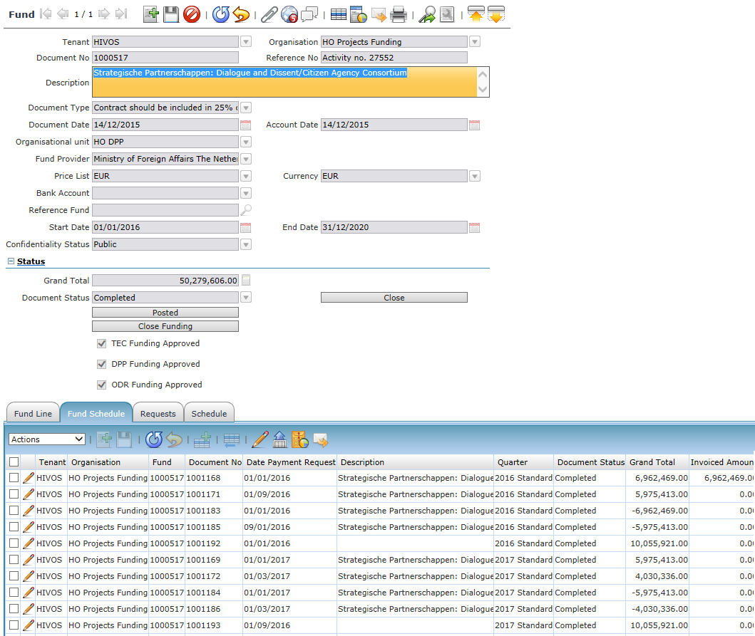

Fund budget window in Osiris

(4.1.8) iati-activities→iati-activity→budget
Only for parent activities.
XML attribute | value
type | 1
→period-start iso-date | AFGO_FUNDSCHEDULE.AFGO_QUARTER_ID  round to 1st of January
→period-end iso-date | AFGO_FUNDSCHEDULE.AFGO_QUARTER_ID  round to 31st of December
type: 1 => Orignal.
Documentation (type): http://iatistandard.org/202/codelists/BudgetType/

(4.1.8) iati-activities→iati-activity→budget→value
Only for parent activities.
XML attribute | value
currency | AFGO_FUNDSCHEDULE.C_CURRENCY_ID
value-date | = period-start iso-date
 | SUM (AFGO_FUNDSCHEDULE.GRANDTOTAL) GROUP BY AFGO_QUARTER_ID WHERE AFGO_FUND_ID_ID...

Transactions
The Guidelines emphasis lays on transactions of the following types:
- Incoming Funds
- Commitment
- Disbursement
- Expenditure
11. Incoming Commitment
The numbered list corresponds with http://iatistandard.org/202/codelists/TransactionType/
Contractline / AFGO_COMMITMENTLINE can be seen as transactions of type 11 (Incoming Commitment) in IATI.
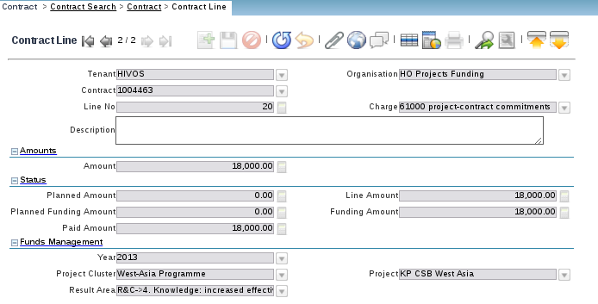
Contractline tab in Osiris

The payment made tab in the contract window can be seen as transactions of type 3 (Disbursement) or type 4 Expenditure in IATI. They can be queried via the HIVO_RV_COMMITMENTALLOCATION view.

4.1.8) iati-activities→iati-activity→transaction (type 1)
Only for parent activities. For each fundschedule:
XML attribute | value
→transaction-type code | 1
→transaction-date iso-date | AFGO_FUNDSCHEDULE.DATEINVOICED
→provider-org→ref | XM-DAC-7
→provider-org→provider-activity-id | AFGO_FUND.REFERENCENO

4.1.8) iati-activities→iati-activity→transaction→value
Only for parent activities.
XML attribute | value
currency | AFGO_FUNDSCHEDULE.C_CURRENCY_ID
SUM (AFGO_FUNDSCHEDULE.INVOICEDAMT) GROUP BY AFGO_QUARTER_ID WHERE AFGO_FUND_ID_ID
AND AFGO_FUNDSCHEDULE.DATEINVOICED <= sysdate

type 1 | Incoming Funds | Funds recieved for use on the activity, which can be from an external or internal source.
Documentation (type): http://iatistandard.org/202/codelists/TransactionType/

4.1.8) iati-activities→iati-activity→transaction (type 2)
Only for parent activities. For each fundschedule:
XML attribute | value
→transaction-type code | 2
→transaction-date iso-date | AFGO_FUNDSCHEDULE.DATEINVOICED
→provider-org→ref | XM-DAC-7
→provider-org→provider-activity-id | AFGO_FUND.REFERENCENO

4.1.8) iati-activities→iati-activity→transaction→value
Only for parent activities.
XML attribute | value
currency | AFGO_FUNDSCHEDULE.C_CURRENCY_ID
 | SUM (AFGO_FUNDSCHEDULE.GRANDTOTAL) GROUP BY AFGO_QUARTER_ID WHERE AFGO_FUND_ID_ID...

type 2 | Commitment | A firm, written obligation from a donor or provider to provide a specified amount of funds, under particular terms and conditions, for specific purposes, for the benefit of the recipient.
Documentation (type): http://iatistandard.org/202/codelists/TransactionType/

4.1.8) iati-activities→iati-activity→transaction (type 3 or 4)
Only for child activities. For each payment made:
XML attribute | value
→transaction-type code | 3 or 4 (see below)
→transaction-date iso-date | HIVO_RV_COMMITMENTALLOCATION.DATETRX
→receiver-org→narrative | C_BPARTNER.NAME

4.1.8) iati-activities→iati-activity→transaction→value
Only for child activities.
XML attribute | value
currency | HIVO_RV_COMMITMENTALLOCATION.C_CURRENCY_ID
HIVO_RV_COMMITMENTALLOCATION.PAYAMT
AND HIVO_RV_COMMITMENTALLOCATION.DATETRX <= sysdate

Most payment will go to other organisations that are required to report to IATI these have type 3. Payments for goods and services (like web site builders and so on) fall out of the scope of IATI. A hard coded list is provided for organisations that should fall under type 4.

type 3 | Disbursement | Outgoing funds that are placed at the disposal of a recipient government or organisation, or funds transferred between two separately reported activities.Under IATI traceability standards the recipient of a disbursement should also be required to report their activities to IATI.

type 4 | Expenditure | Outgoing funds that are spent on goods and services for the activity. The recipients of expenditures fall outside of IATI traceability standards.
Documentation (type): http://iatistandard.org/202/codelists/TransactionType/

4.1.8) iati-activities→iati-activity→transaction (type 11)
Only for child activities. For each contractline:
XML attribute | value
→transaction-type code | 11
→transaction-date iso-date | AFGO_COMMITMENTLINE.UPDATED
→provider-org→ref | NL-KVK-41198677
→provider-org→provider-activity-id | NL-KVK-41198677-AFGO_FUND-AFGO_FUND.REFERENCENO

4.1.8) iati-activities→iati-activity→transaction→value
Only for child activities.
XML attribute | value
currency | AFGO_COMMITMENT.C_CURRENCY_ID
AFGO_COMMITMENTLINE.LINENETAMT WHERE
AFGO_FUND_ID = … ¹

type 11 | Incoming Commitment | A firm, written obligation from a donor or provider to provide a specified amount of funds, under particular terms and conditions, reported by a recipient for this activity.

In case a contract has multiple donors, it is not possible to use grandtotal from the contract in the activity as this would sum the donated amounts of various donors. To avoid this we are using contractlines instead.
¹ afgo_fund can be obtained by joining child table afgo_fundallocation with afgo_commitmentline.
Argumentation (type): from the Guidelines:
Furthermore, the financial relation between parent Activity and child Activities, is represented through an Incoming Commitment transaction, with provider organisation Hivos and parent Activity’s iati-identifier.
http://iatistandard.org/202/codelists/TransactionType/

4.1.9) iati-activities→iati-activity→document-link
A link to an online, publicly accessible web page or document. This implies some IT infrastructure should be in place. The following documents are to be published:
- Annual analysis report on progress of the activity (according to contractual obligation)
XML attribute | value
url
format | application/octet-stream  http://iatistandard.org/202/codelists/FileFormat/
→ title narrative | Review of project performance and evaluation  http://iatistandard.org/202/codelists/DocumentCategory/
→ category code | A07  http://iatistandard.org/202/codelists/DocumentCategory/
→ langauge code | en
→ document-date | ASSESSMENT

Planning: The document link will be implemented in Q4 2016.

4.1.10) iati-activities→iati-activity→related-activity
Only for child activities.
Reference from Osiris Project Cluster to Osiris Fund as described in figure 2 and the Program Funding Use Case chapter.
XML attribute | value
ref | NL-KVK-41198677-AFGO_FUND-AFGO_FUND.REFERENCENO
type | 1

type: 1 => parent
Argumentation (type): from the Guidelines:
Another separately reported IATI activity that is related to this one. If you report activities at different levels (see the Use cases Program funding and Partnerships), this element MUST be used to report the relationship between the program and the project activities.
The ministry chooses to only use the ‘parent’ relation, pointing from the child to the parent.
Documentation (type): http://iatistandard.org/202/codelists/RelatedActivityType/

4.1.11) iati-activities→iati-activity→result
A container for reporting outputs, outcomes, impacts and other results that stem directly from the activity. This may be repeated for each type of result reported.
- Assessment via schedule item of type outcome statement on project cluster.
XML attribute | value
type | 2
→ title narrative
indicator
indicator → measure
indicator → title narrative
2 => outcome
http://iatistandard.org/202/codelists/ResultType/

